Glossary of art historical terms:

Abstract –
1, Art that is non-representational, purely autonomous and makes no reference to an exterior world.
2, Art that abstracts its objects from the visible world (makes them less coherent as objects, as in cubism.)

Acanthus – Mediterranean plant with thick, prickly leaves. Thought to be the inspiration for Corinthian columns.

Aerial Perspective – The perception of distance in a painting, specifically relating to the lightening colour of the landscape the further into the distance it goes.

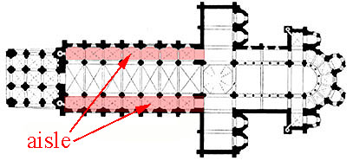
Aisle – Part of a church or hall which runs parallel to the main span of the building (often called a nave) and divided from it by columns or occasionally a screen wall.
Altarpiece – A devotional painting or sculpture placed on, above or behind an altar.

Ambulatory – An aisle surrounding the choir or chancel of a church or cathedral.

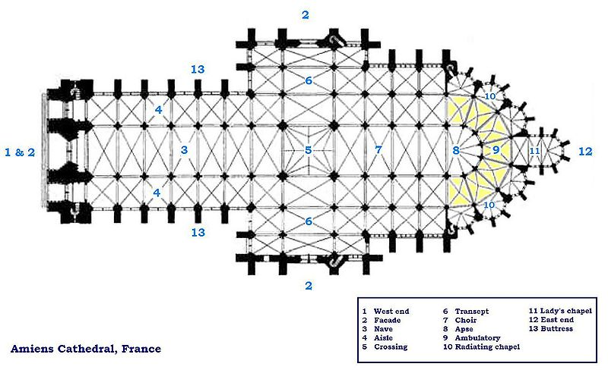
Ambulatory

Amphitheatre – An elliptical or circular space surrounded by rising tiers of seats. Used by the Romans for gladiatorial combat.

Apse – Vaulted semicircular termination of a building, usually in a church.

Aqueduct – Artificial channel used for carrying water, usually an elevated structure supported on arches.

Arabesque – Intricate surface decoration of plant forms, spirals knots etc. without human figures.
Arcade – A range of arches on piers or columns, either free standing or attached to a wall.

Arch – A curved span over a two supports, which allows weight from above to be channeled through the supports.
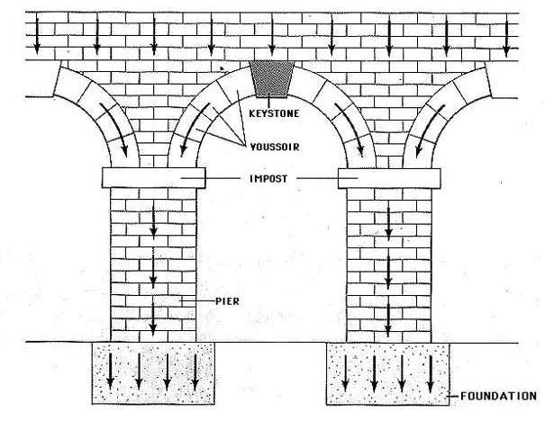
Arch

Architrave – The lowest part of an entablature (see Frieze)

Asymmetry – Absence of symmetry.

Avant Guard – In the vanguard, or those in advance or ahead of their time.

Axis – In art of architecture, an imaginary line which passes centrally through a figure or composition, façade or ground plan to give it an impression of balance.
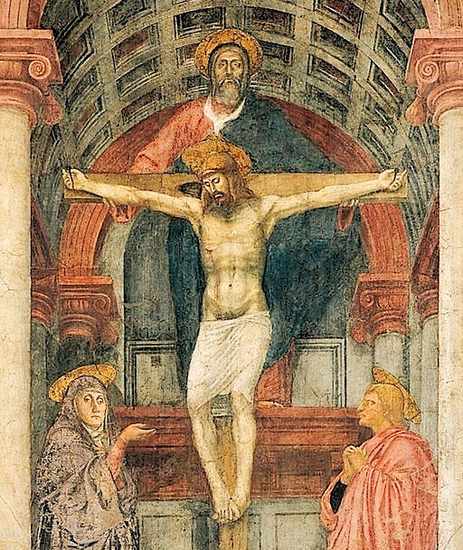
Example of lines of axis. These can help reveal artistic composition.

Baptistery – A building for Christian baptismal rites. Usually separate from the church.

Basilica – Ancient Roman colonnaded building used for civic functions. Became the ground plan for early Christian churches.
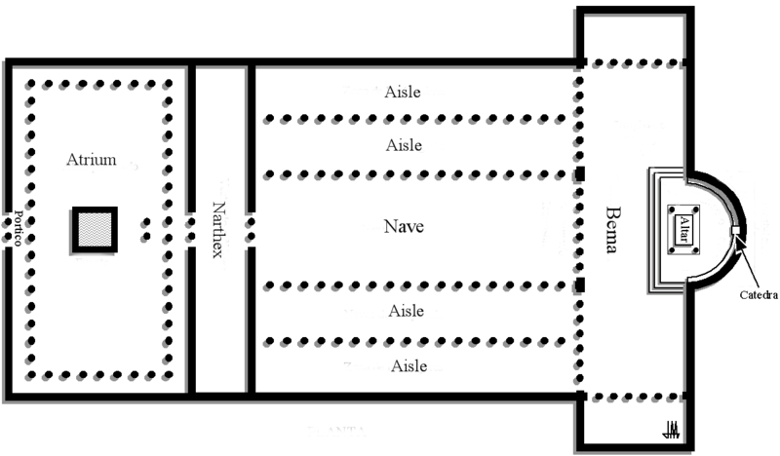
Basilica ground plan.
Boss – A (usually) decorative projection used to cover the intersection of vaults.

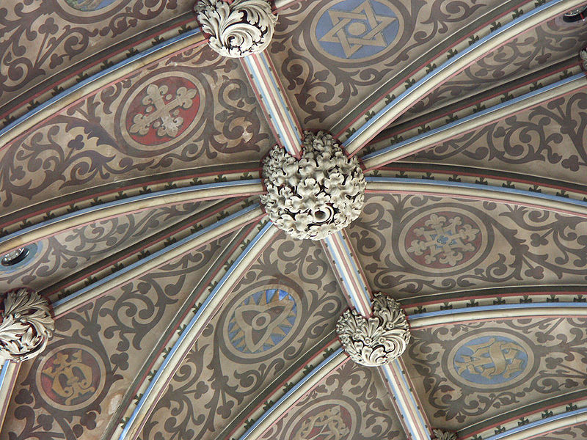
Boss.

Buttress – A projecting support built against a wall to give it additional strength, usually to counteract the lateral thrust of an arch or vault.
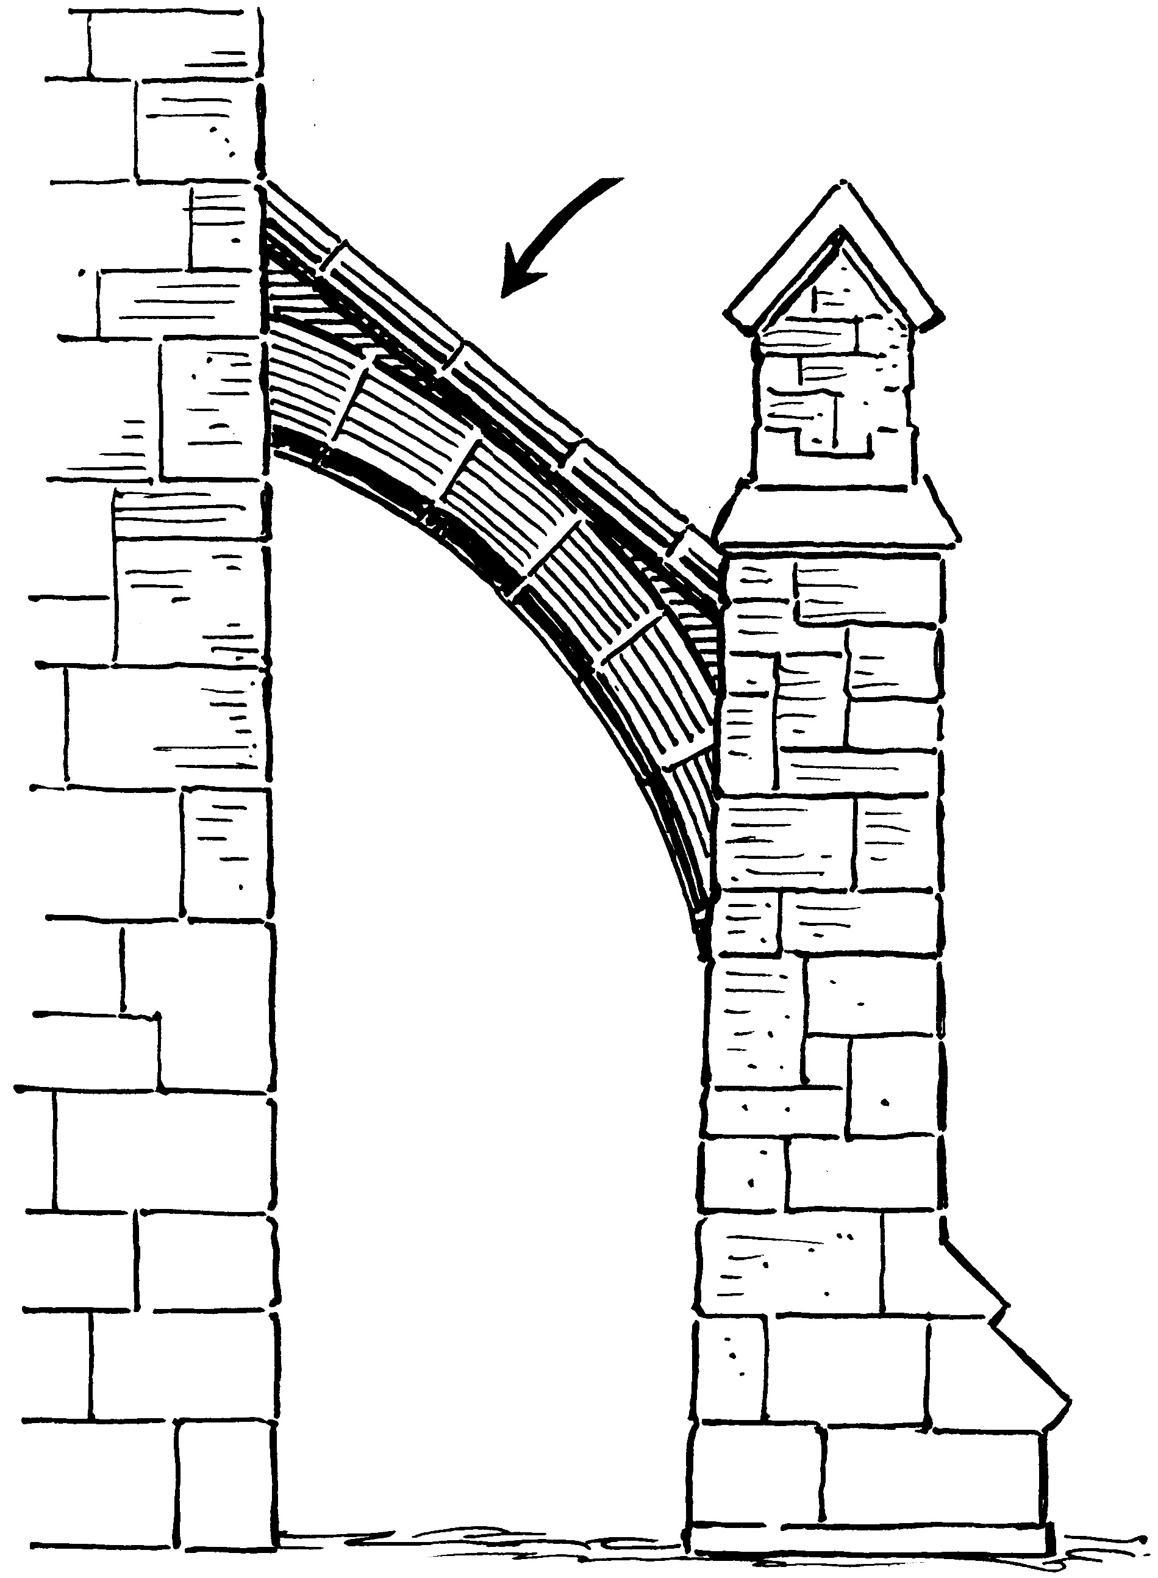

Cantilever – A projecting beam, canopy etc. supported by a downward force behind the fulcrum. Usually anchored at one end.
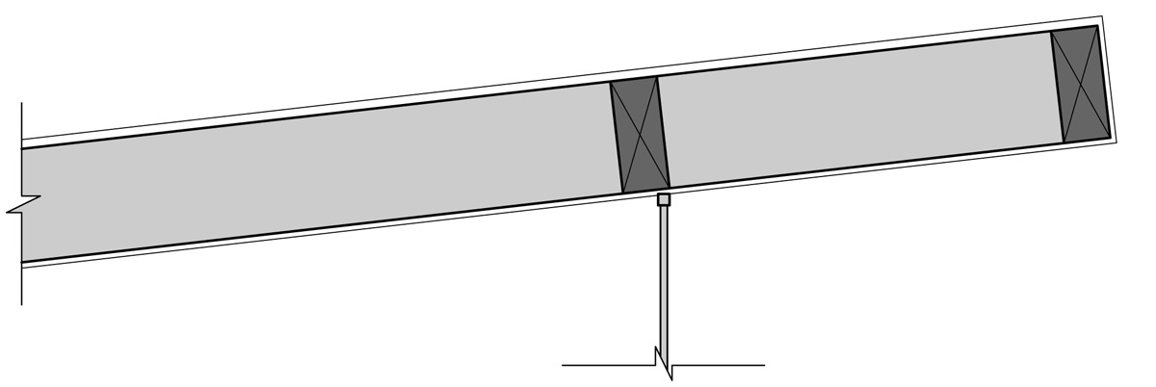

Canvas – A course unbleached cloth, woven from hemp or flax and used in the West as a support for oil painting since the 15th Century.

Capital – The top portion of a column (see orders)

Caryatid – A full or half length statue of a female used as a support instead of a column.

Chalice – Wine cup used for drinking the sacramental wine in Christian Mass or Communion.

Chancel – The east end of a church in which the altar is placed. Reserved for the clergy and choir and occasionally hidden by a screen.

Chiaroscuro – In painting, the manipulation of light and dark to give the effect of modeling.

Choir – The part of a church where the service is sung. Part of the chancel.

Clerestory – The upper stage of the nave walls of a basilica or church, rising above the aisle roofs and pierced with windows.

Coffering – Decoration of a ceiling, vault or arch consisting of sunken square or polygonal shapes.

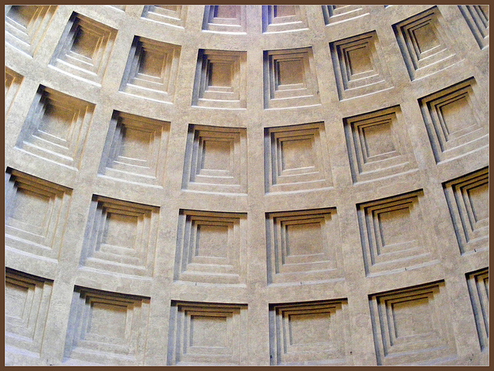
Example of coffering from the dome of the Pantheon in Rome.

Collage – A composition made by gluing pieces of paper, cloth etc. on a canvas or other ground.

Colonnade – A row of columns carrying an entablature or arches.

Compound Pier – Like a column, but with several engaged or semi-detached shafts against its faces.

Contour – An outline defining a form.
Contraposto – A pose in which one part of the body is twisted in an opposite direction to another.

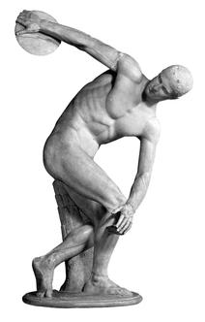

Cornice – In classical architecture the top projecting entablature, or a projecting ornamental molding along the top of a wall.

Cross-Hatching – A method of shading in drawings and engravings by superimposing hatching or lines running in opposite directions.

Cruciform – Shaped like a cross.

Cupola – A dome.

Diptych – A picture or relief on two hinged panels.

Engaged column – One that is attached to or sunk into a wall or pier.

Entasis – The slight convex curve in the shaft of a column.

Façade – Architecturally emphasized front or face of a building.

Fenestration – The arrangement of windows in a building.

Figurative Art – Depictions of the visible world, not necessarily including human or animal figures.

Fluting – Shallow concave grooves running vertically on the shaft of a column, pilaster or other surface.

Foreshortening Perspective – Applied to a single form e.g. a foot represented as pointing out of, not in line with, a pictorial plane.
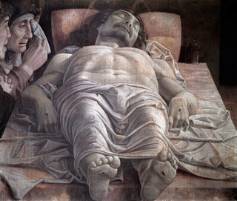
Example of foreshortening. Jesus’ feet appear to emerge from the painting.
Forum – An open space surrounded by public buildings in an ancient Roman town. A political and civic center.

Fresco – Wall and ceiling painting on fresh (fresco) moist lime plaster with pigments ground together so that they are absorbed into the plaster.
Frieze – The middle division of an entablature. More loosely, a sculptured or decorated horizontal band.

Functionalism - The theory that a building, piece of furniture, or other object should be designed primarily to fulfill its material function and its form should be determined exclusively by its function.

Gable – A triangular section at the end of a pitched roof.

Genre Painting – A painting of everyday life.

Genres – The various categories of painting e.g. history, landscape, portrait, still life etc.

Golden Section or Golden Mean – An irrational proportion, probably known to the ancient Greeks and used by Renaissance art theorists. Essentially the division of a composition so that the smaller part is to the larger part, what the larger part is to the whole. Roughly 5:8 as a fraction.
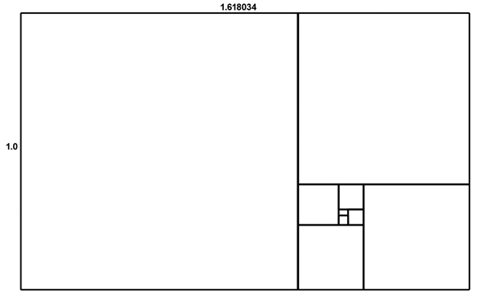

Diagram of diminishing golden means.
Ground – The surface on which a painting is executed.

Halo – The circular light behind a sacred persons head. Similar is a glory or nimbus, which is a radiant holy light that surrounding a holy person.

Hatching – Parallel lines indicating shadow in a drawing or engraving.

Highlight – In a painting, a spot of the highest or lightest value, usually white.

History Painting – A figurative painting of a scene from classical mythology, the Bible, the lives of saints, or an historical event.

Icon – A small, portable panel painting of Christ, the Virgin and Child or the saints, produced for Greek or Russian Orthodox Christians.

Iconoclasm – The prohibition or destruction of religious images.

Iconography – The study of the meaning of visual images whether conveyed directly or through symbols or allegories.

Iconology – The study of the meaning of visual images in relation to their historical-cultural context.

Impasto – Oil paint thickly applied.

Installation – A designed environment set up as an art-work, usually multimedia. Always site specific.

Intensity – Richness or saturation of colour.

Keystone – The central stone of an arch or rib vault.

Linear Style – Paintings in which forms are defined mainly by line, as opposed to those described as painterly.

Lintel – A horizontal beam or stone bridging an opening.

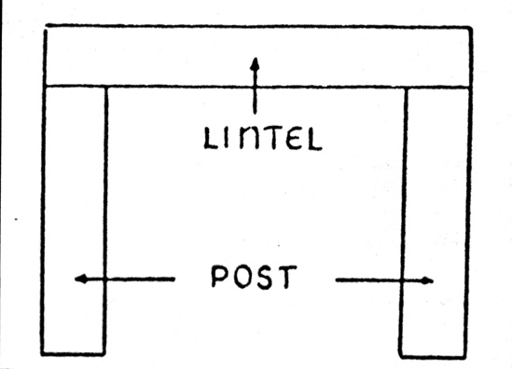

Mass – The three-dimensional bulk of an object, as distinct from the two-dimensional area it covers or the single plane on its surface.

Medium – The process or means used by an artist (e.g. oil on canvas).

Memento Mori – An image intended to serve as a reminder of death, usually a human skull.

Modelling – The process of fashioning materials like clay or wax, and by extension (in painting, drawing etc.) the indication of solid form through shading.

Monochrome – Painting or drawing or photograph in the tones of a single colour.

Mosaic – A pictorial representation made of small coloured stones, or cubes of stone, set in plaster.

Mural – A painting on a wall. Usually, but not always, a fresco.

Nave – The congregational area of a church, flanked by aisles.

Oculus – A circular opening in a wall or ceiling.

Orders – In classical architecture an order consists of a column with base (usually) shaft, capital and entablature, decorated according to one of six accepted models.

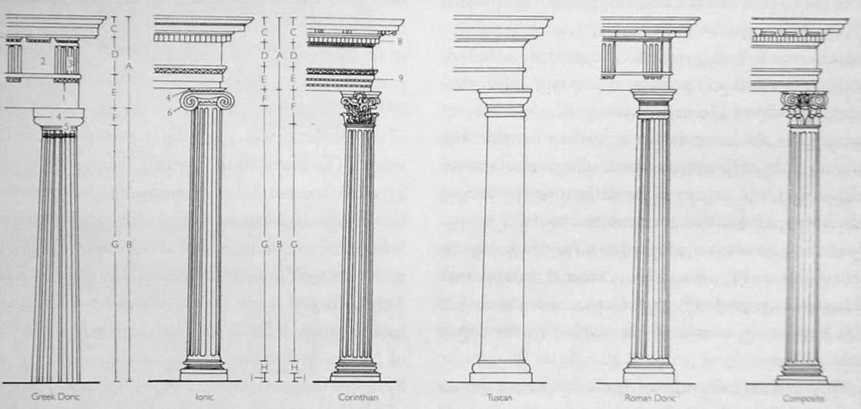
Try to learn Doric, Ionic and Corinthian.
Doric
Ionic
Corinthian

Painterly – Characteristic of a painting in which forms are defined by tone rather than line.

Palette – The range of colours used by an artist.

Patina – The effect produced, either naturally or artificially, on bronze by oxidation. The term is also used figuratively for the surface texture of old objects. Pedestal – In classical architecture, the base supporting a single column or colonnade. More loosely, the base of for a statue, bust, vase or any superstructure.

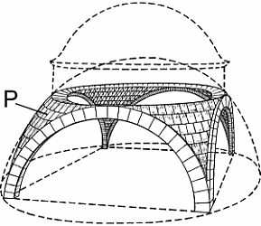
Pediment – A low pitched gable over a portico, door or window.
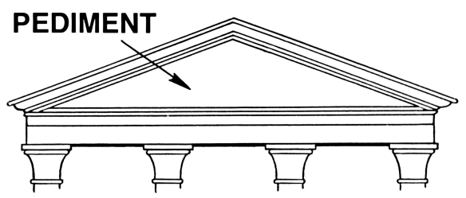
Pendentive – A concave spandrel, leading from the angle of two walls to the base of a circular dome.

Perspective – Systems of representing objects in spatial recession.

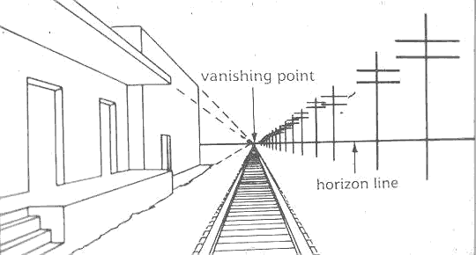

Picture Plane – The flat surface of a picture. If painted according to Western ideas of perspective, it is conceived of as a transparent window between the spectator and the pictorial space.

Pier – A solid masonry support.

Pieta – An image or sculpture of the Virgin Mary with the dead Christ on her lap.

Pigment – The colouring substance, usually a powder, held together by a medium (e.g. oil for paint, gum arabic for watercolour) which allows it to be applied evenly and fixes it to the ground.

Pilaster – A shallow pier projecting only slightly from a wall.

Pillar – A free-standing upright member, distinct from a column in that it need not be circular or conform with the classical orders.

Plan – The horizontal arrangement of one or more buildings or a single part of a building; or a diagram showing such an arrangement.

Plein Air Painting – A painting executed out of doors.

Plinth - The projecting base of a wall or column.

Ploychromy – The use of many colours in a painting, sculpture or building.

Polyptych – A painting or relief, usually an altarpiece on more than three panels.

Portico – A roofed space, open or partly enclosed, forming the entrance, and usually the centerpiece of the façade.

Priming – A coating applied to a surface which is to be painted.

Pulpit – An elevated stand surrounded by a parapet for a preacher or reader in a Christian place of worship.

Relief Sculpture – Sculptural forms projecting from a ground, called high relief when they are at least half in the round, otherwise low relief or bas-relief.

Rib – A projecting band on a ceiling or vault, usually structural but sometimes purely decorative, separating the cells of a groined vault.

Rose Window – A large circular window on the façade of a gothic church.

Rustication – Massive blocks of masonry with roughened surfaces and sunk joints, often simulated in plaster.

Sacra Conversazione – The Virgin and Child with saints depicted in such a way as they occupy a single pictorial space.

Saturation – The relative brightness or dullness of colour, also called intensity.

Scuola – Venetian term for a religious confraternity of laymen and its premises. Similar to a medieval guild.

Sfumato – A soft, misty effect attained in oil painting mainly by the use of glazes. Leonardo da Vinci was particularly good at this.

Spandrel – A triangular area between the side of an arch, the the horizontal drawn from its apex the vertical from between two arches in an arcade.

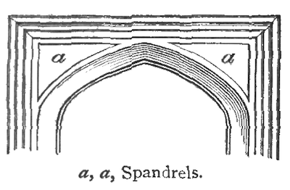
Still Life – A representation of inanimate objects such as fruit, flowers, dead animals or household objects.

String Course – A continuous horizontal band in, or more usually projecting from, an exterior wall.

Stucco – Various types of plaster used as a protective and decorative covering for walls. Often used for relief decorations on ceilings and interior walls.

Swag – An ornamental motif resembling a piece of cloth draped over two supports.

Symmetry – The correspondence of parts of an object or its decorations on either side of a real or imaginary line.

Example of symmetry in architecture.

Tempera – Painting with powdered pigments made workable (tempted) with egg yolk and water, a technique practiced in Europe from the early Middle Ages till the 16th Century.

Terracotta – Baked or fired but unglazed clay, usually reddish brown in colour.

Tondo – A painting or relief of circular shape.

Tracery – Ornamental intersecting work in the upper part of a Gothic window, screen or panel, or on the surface of a vault. There are two kinds: plate and bar tracery. Plate tracery looks like holes punched into a solid wall with a cookie cutter, whilst bar tracery looks like a complex and fragile construction of ribs.
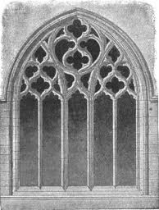
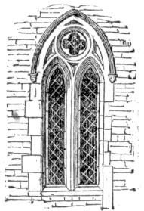
Bar tracery
Plate tracery

Transverse arch – An arch separating one bay of a vault from another in Romanesque and Gothic architecture.

Triglyph – Three vertical lines marked onto a square block which forms part of the entablature on a Doric Order. (See Orders)

Triptych – A painting on three panels.

Triumphal arch – A free standing monumental gateway of a type originated in Rome, but much used till the 19th century for its symbolism of empire and conquest (e.g. Marble arch)

Trompe L’oeil – An illusionistic painting intended to ‘decieve the eye’.

Tympanum – The area between the lintel of a doorway and the arch above it, also the triangular or segmental space enclosed by the moldings of a pediment.

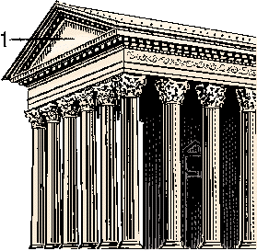
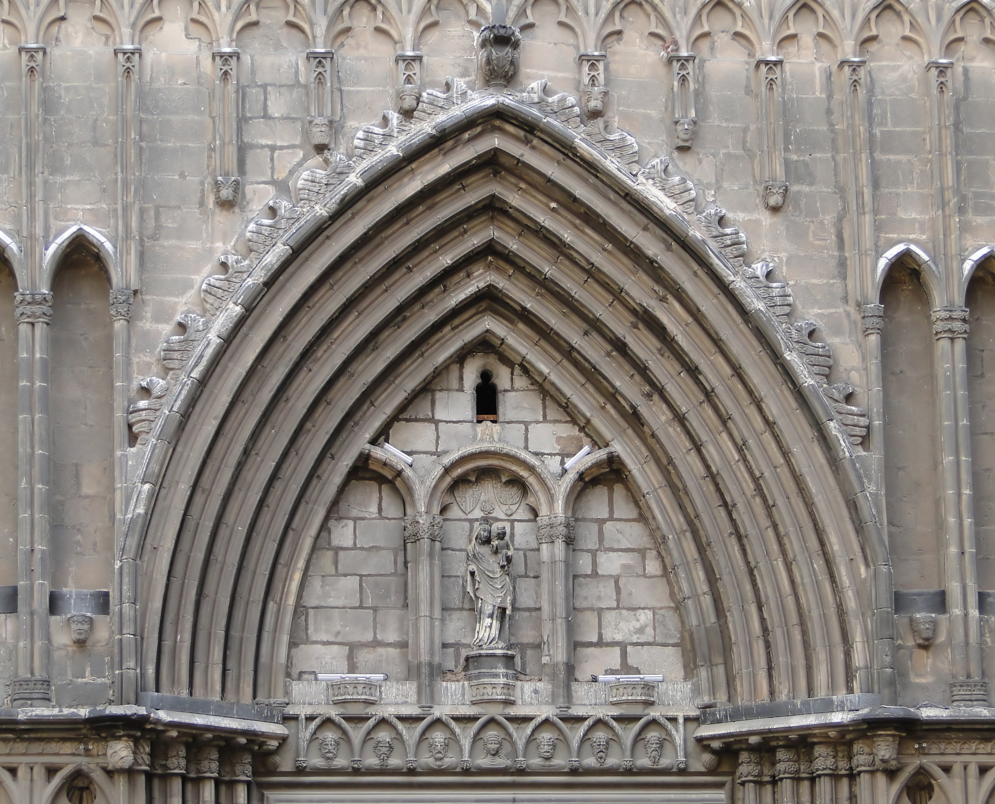
Tympanum

Underpainting – The initial layers of paint, especially on oil painting, but also tempera and others.

Vanishing point – In an image observing the laws of linear perspective, the point on which the lines defining depth in a painting meet. See vanishing point on perspective.

Varnish – A solution of resin applied as a protective coat over a painting, sometimes tinted to modify the colours of the pigment beneath it.

Vaulting – A masonry roof or ceiling constructed on the principle of the arch. The simplest form is a tunnel or barrel vault of continuous or semicircular or pointed section, unbroken by cross vaults (a rather than b) The intersection of two tunnel vaults of identical shape produces a groin vault (b).
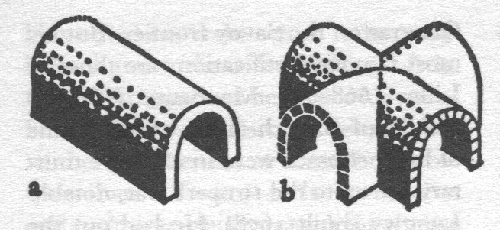
Volume – Space enclosed by mass e.g. the interior of a building.

Volute – The spiral scroll on capitals of the Ionic and, less prominently, Corinthian orders (see orders). Traditionally thought to have come from the spiral of a ram’s horns.

Voussoir – A wedge-shaped brick or stone forming one of the segments of an arch.

